PF LAB 6

TASK 1:

Code:
#include<stdio.h>

main(){
char check;
int number;
int even = 0;
int odd = 0;

printf("enter 'y' to enter number and 'n' for exit: \n");
scanf("%c" , &check);
while (check == 'y'){
printf("enter a number: ");
scanf("%d" , &number);
if (number%2 == 0){
printf("even number was entered\n");
even = even + 1;
}
else{
printf("odd number was entered\n");
odd = odd + 1;
}
printf("Do you want to continue?(y for yes / n for no): \n");
scanf(" %c" , &check);
}
printf("you entered %d even numbers and %d odd numbers" ,even ,odd);

}

OUTPUT:

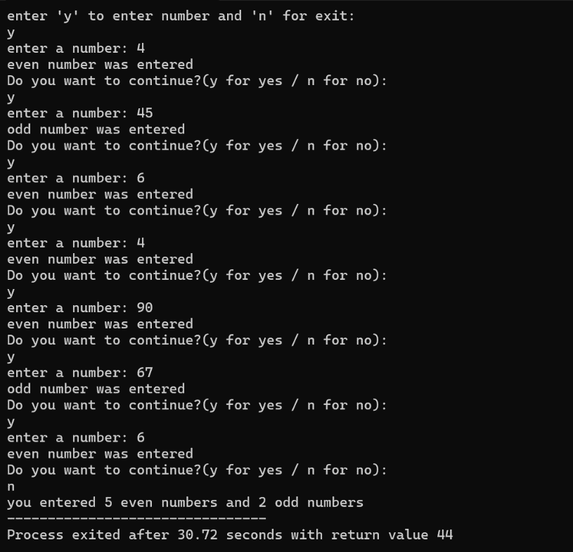

TASK2:

Code:
#include<stdio.h>

main(){
int primecount = 0;
int primesum = 0;
int number;

printf("enter the number: ");
scanf("%d" , &number);
for(int i = 2 ; i <= number ; i++){
int primecheck = 1;
int count = 2;
while ( count < i){
if (i % count == 0){
primecheck = 0;
break;
}
count = count + 1;
}
if (primecheck == 1){
primecount++;
primesum = primesum + i;
printf("the number %d is a prime number\n" , i);
}
}
printf("there were %d prime numbers\n" , primecount);
printf("the sum of prime numbers is %d\n" , primesum);

}

OUTPUT:
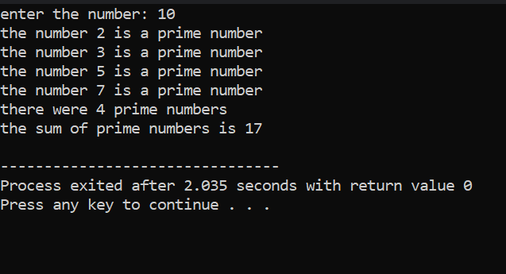

TASK 3:

CODE:
#include<stdio.h>

main(){
int number;
int firstvalue = 0;
int secondvalue = 1;
int nextvalue;
int sum;
int count = 3;

printf("enter number: ");
scanf("%d" , &number);

if (number == 1){
printf("%d " , firstvalue);
sum = firstvalue + secondvalue;
}
else if( number == 2){
printf("%d , %d" , firstvalue , secondvalue);
sum = firstvalue + secondvalue;
}
else{
printf("%d , %d" , firstvalue,secondvalue);
sum = firstvalue + secondvalue;
while (count <= number){
nextvalue = firstvalue + secondvalue;
printf(", %d" , nextvalue);
sum = sum + nextvalue;
firstvalue = secondvalue;
secondvalue = nextvalue;
count++;

}
}
printf("\n");
printf("%d" , sum);
}

OUTPUT:
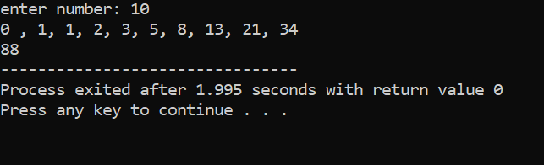

TASK4:

CODE:
#include<stdio.h>

main(){
char check , letter;
int vowel=0;
int consonant=0;

printf("enter 'y' to start entering letters or enter 'n' to exit: \n");
scanf(" %c" , &check);
while (check == 'y'){
printf("enter your letter: \n");
scanf(" %c" , &letter);
switch (letter){
case 'A':
case 'a':
vowel++;
break;
case 'e':
case 'E':
vowel++;
break;
case 'i':
case 'I':
vowel++;
break;
case 'o':
case 'O':
vowel++;
break;
case 'u':
case 'U':
vowel++;
break;
default:
consonant++;
break;
}
printf("enter 'y' to continue or 'n' for exit: ");
scanf(" %c" , &check);
}
printf("you entered %d vowels\n" ,vowel);
printf("\nyou entered %d consonants" , consonant);
}

OUTPUT:
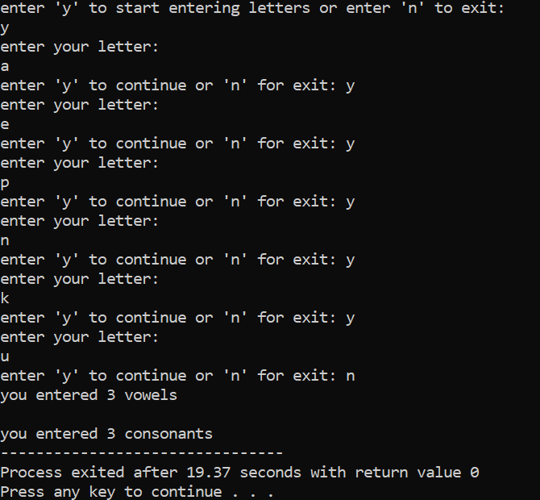

Task5
#include<stdio.h>

main(){
int number;
int factorial = 1;
printf("enter number: ");
scanf("%d" , &number);
for(int i = 1 ; i <= number ; i++){
factorial = i * factorial;
}
printf("factorial: %d" , factorial);
}

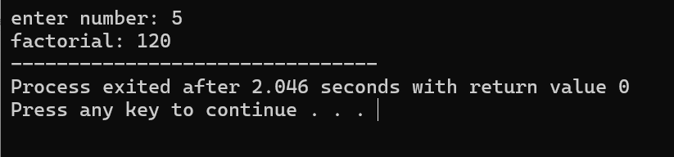

Task 6
#include<stdio.h>
main(){
int grade;
int total = 0;
int count = 0;
int grade1 = 0;
int grade2 = 0;
int grade3 = 0;
int gradecheck = 0;
float avg;

printf("enter your grade (between 0 and 100) or '-1' to exit: \n");
scanf("%i" , &grade);
if (grade>=0 && grade<=100){
gradecheck = 1;
}
while (gradecheck == 0 && grade !=-1){
printf("enter valid grade or '-1' to exit: \n");
scanf("%i" , &grade);
if (grade>=0 && grade<=100){
gradecheck = 1;
}
}
while(grade != -1){
printf("your grade is: %i\n" , grade);
total = total + grade;
count++;
if (grade > 70 ){
grade1++;
}
else if( grade>=50 && grade<=70){
grade2++;
}
else{
grade3++;
}
printf("enter your grade or '-1' to exit: \n");
scanf("%i" , &grade);
}

avg = (total / count);
printf("your average grade is: %.2f\n" , avg);
printf("grades above 70: %d\n" , grade1);
printf("grades between 50 and 70: %d\n" , grade2);
printf("grades lower than 50: %d\n" , grade3);

}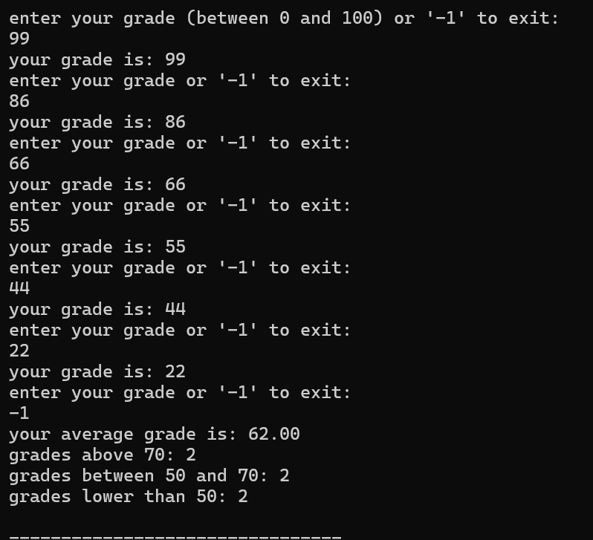
Task 7
#include<stdio.h>

main(){
int initialbalance = 5000;
int userinput;
int deposit = 0;
int withdrawl = 0;
printf("enter deposit/withdrawl amount or '0' for exit: ");
scanf("%i" , &userinput);
while (userinput != 0){
if (userinput > 0){
deposit++;
initialbalance = initialbalance + (userinput);
printf("your balance after deposit is: %d\n" , initialbalance);
}
else if (userinput < 0){
withdrawl++;
initialbalance = initialbalance + (userinput);
printf("your balance after deposit is: %d\n" , initialbalance);
}
printf("enter deposit/withdrawl amount or '0' for exit: \n");
scanf("%i" , &userinput);
}
printf("amount of withdrawls: %d\n" , withdrawl);
printf("amount of deposits: %d\n" , deposit);

}
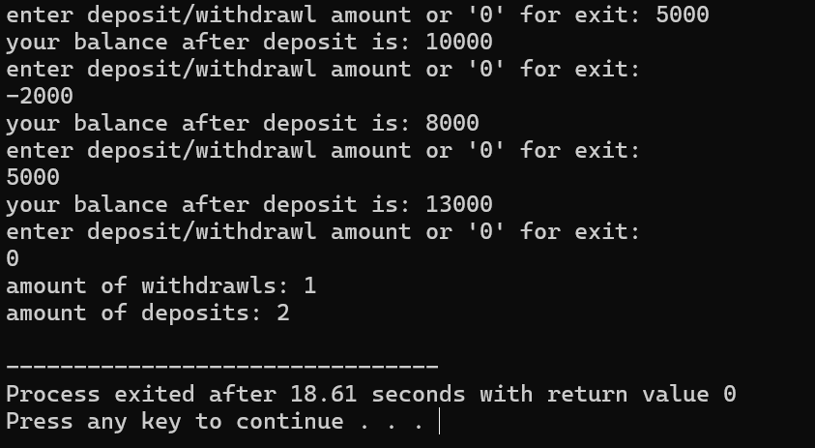
Task 8
#include<stdio.h>

main(){
int result , number;
printf("enter number: ");
scanf("%d" , &number);
for (int i = 1 ; i <= 10 ; i++){
result = (i * number);
printf("%d x %d = %d\n" , number , i , result);
}
}

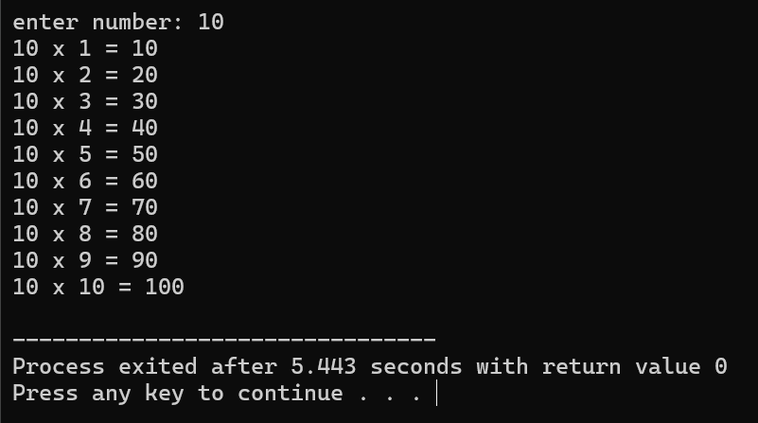

TASK 9:
#include<stdio.h>
#include<string.h>

main(){
char userinput[50];
int check = 0;
int largest = 0;
int smallest = 0;
int number;
printf("enter 'yes' to enter number or 'no' to exit: \n");
scanf("%s" , userinput);
if (strcmp(userinput , "yes") == 0){
check = 1;
}
else if (strcmp(userinput , "no") == 0){
check = 0;
}
while (check == 1){
printf("enter number: \n");
scanf("%i" , &number);
if (number <= smallest){
smallest = number;
}
else if (number >= largest){
largest = number;
}
printf("largest number: %d\n" , largest);
printf("smallest number: %d\n" , smallest);
printf("Do you want to continue? (yes/no): \n");
scanf("%s" , userinput);
if (strcmp(userinput , "yes") == 0){
check = 1;
}
else if (strcmp(userinput , "no") == 0){
check = 0;
}
}

printf("largest number you entered: %d\n" , largest);
printf("smallest number you entered: %d\n" , smallest);

}
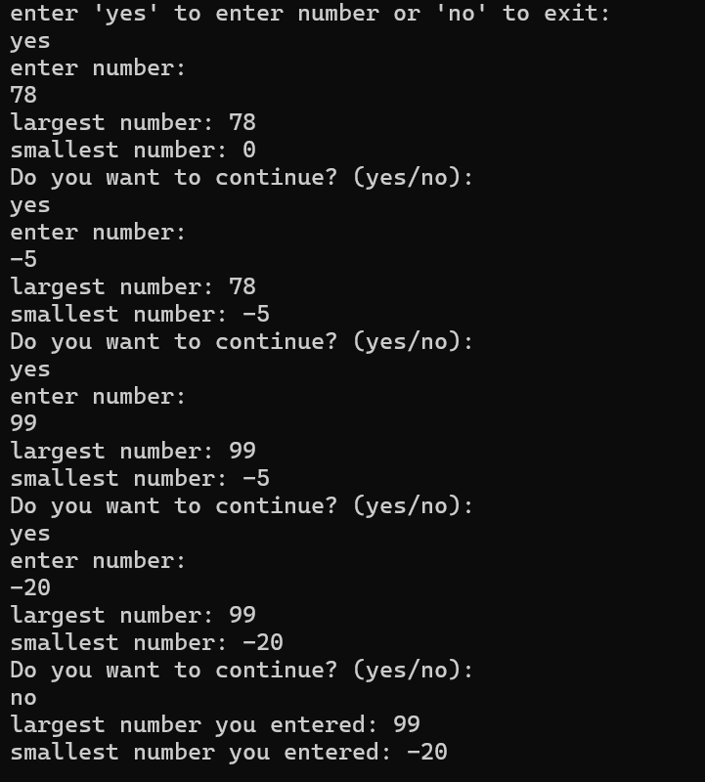

TASK 10:
#include<stdio.h>
#include<string.h>

main(){
char userinput[50];
int check = 0;
int number;
int sum = 0;
printf("enter 'yes' to enter number or 'no' to exit: \n");
scanf("%s" , &userinput);
if (strcmp(userinput , "yes") == 0){
check = 1;
}
else if (strcmp(userinput , "no") == 1){
check = 0;
}
while (check == 1){
printf("enter number: \n");
scanf("%d" , &number);
sum = sum + number;
printf("current total: %d\n" , sum);
printf("Do you want to enter another number? (yes/no): \n");
scanf("%s" , &userinput);
if (strcmp(userinput , "yes") == 0){
check = 1;
}
else if (strcmp(userinput , "no") == 1){
check = 0;
}
}
}



